## 

## Majlis Arts and Science College, Puramannur

**(Affiliated to the University of Calicut)**

## PROJECT REPORT

## On

## EBUCKET

## Submitted in partial fulfillment of the requirements for the award of the degree of

## Bachelor of Computer Science

## UNIVERSITY OF CALICUT

## 

**Submitted By:**

MUSHFIRA KT (MSATSCS019)

MUHAMMED SHIBIN K(MSATSCS013)

MOHAMMED SHIBILI K(MSATSCS006)

**Guided By:**

**AJAYKUMAR U**

**Assistant Professor,**

**Dep. of computer science**

**2021-22**

## 

## Majlis Arts and Science College, Puramannur

**(Affiliated to the University of Calicut)**

## PROJECT REPORT

## On

## EBUCKET

## Submitted in partial fulfillment of the requirements for the award of the degree of

## Bachelor of Computer Science

## UNIVERSITY OF CALICUT

**Submitted By:**

MUSHFIRA KT (MSATSCS019)

MUHAMMED SHIBIN K(MSATSCS013)

MOHAMMED SHIBILI K(MSATSCS006)

**Guided By:**

**AJAYKUMAR U**

**Assistant Professor,**

**Dep. of computer science**

**2021-22**

## Majlis Arts and Science College, Puramannur

**(Affiliated to the University of Calicut)**



**DEPARTMENT OF COMPUTER SCIENCE**

***Certificate***

***This is to certify that the project entitled EBUCKET submitted in the partial fulfillment of the requirement for the award of the Degree of Bachelor of Computer Science, University of Calicut, is a bonafide record of the project work done by MUSHFIRA KT (MSATSCS019),MUHAMMED SHIBIN K(MSATSCS013),MOHAMMED SHIBILI K(MSATSCS006)during the academic year 2021-2022 in the Department of Computer Science, Majlis Arts and Science College, Puramannur under my supervision and guidance.***

**Mr.AjayKumar.U**

**Assistant Professor**

**Department of ComputerScience**

**Submitted for the University exam held on …………..**

**Internal Examiner External Examiner**

# ACKNOWLEDGEMENT

With profound sense of gratitude, we wish to express my sincere thanks to Dr Mohamedali, Principal, Majlis Arts and Science College for giving an opportunity to undertake this project.

We have great pleasure in expressing my profound gratitude to Mr. Ajayakumar U, Head of the Department of Computer Science for giving the valuable help during the project work.

We gratefully acknowledge my internal guide **AJAYKUMAR,** Asst.Professor , Department of Computer Science, Majlis Arts and Science College for his encouragement till the end of the project.

Last but not least, I would like to express my sincere thanks to the God almighty for his constant love and grace that he has bestowed upon us. Finally, I thank my parents, family members and beloved friends for their moral support and encouragement without which I have not been able to follow my dreams.

# DECLARATION

I hereby declare that this project work entitled **EBUCKET** submitted to the University of Calicut in partial fulfillment of requirements for the award of Bachelor of Computer Science is a record of original work done by **MUSHFIRA KT (MSATSCS019),MUHAMMED SHIBIN K(MSATSCS013),MOHAMMED SHIBILI K(MSATSCS006)** under the guidance of **AJAYKUMAR U,**Asst.Professor, Department of Computer Science, Majlis Arts and Science College Puramannur.

Mushfira KT ……….

Muhammed Shibin K .………

Mohammed shibili K ……….

Place:Puramannur.

Date:

**CONTENTS**

|  |  |  |  |
| --- | --- | --- | --- |
| **SI.NO** | | **CONTENTS** | **PAGE NUMBER** |
| **1** |  | **INTRODUCTION** |  |
|  | 1.1 | ABSTRACT | **1** |
| **2** |  | **SYSTEM STUDY** |  |
|  | 2.1 | EXISTING SYSTEM |  |
|  | 2.2 | PROPOSED SYSTEM |  |
| **3** |  | **SYSTEM ANALYSIS** |  |
|  | 3.1 | FEASIBILITY STUDY |  |
| **4** |  | **SYSTEM REQUIREMENTS** |  |
|  | 4.1 | SOFTWARE SPECIFICATION |  |
|  |  | HARDWARE SPECIFICATION |  |
| **5** |  | **SYSTEM DESIGN** |  |
|  | 5.1 | SYSTEM ARCHITECTURE |  |
|  | 5.2 | INPUT DESIGN |  |
|  | 5.3 | OUTPUT DESIGN |  |
|  | 5.4 | DATA FLOW DIAGRAM |  |
|  | 5.5 | DATABASE DESIGN |  |
|  | 5.6 | MODULE DESCRIPTION |  |
| **6** |  | **SYSTEM IMPLEMENTATION & TESTING** |  |
|  | 6.1 | SYSTEM TESTING |  |
|  | 6.2 | SYSTEM IMPLEMENTATION |  |
|  | 6.3 | DOCUMENTATION |  |
| **7** |  | **FUTURE ENHANCEMENT** |  |
| **8** |  | **CONCLUSION** |  |
| **9** |  | **BIBILIOGRAPHY** |  |
| **10** |  | **SAMPLE CODE** |  |
| **11** |  | **SCREENSHOTS** |  |

**1.INTRODUCTION**

* 1. **ABSTRACT**

Management of waste is the major problem of our community.

E-BUCKET will help you to manage your solid wastes, including e - waste in an effective manner. The user can raise a request to collect the waste through their account by providing necessary details.

“E – Bucket” is also an environment friendly app and we can save our nature by using this application. As we know electronic waste contains toxic components that are dangerous to human health, such as mercury, lead, cadmium…etc. It causes human diseases. In our application, we will make an android based application that will help to find solid / e -waste collectors in reasonable prices, User can select the appropriate collecting agent by evaluating the price.

The “E – Bucket” application Intended to people who are facing trouble on manage e -waste. The application will allow user to select his/her role i.e. user or collecting agent. This will lead to the user to login the app. Both user and collecting agent will enter their details. The user can choose the mode of waste from the category, provide the contact information and he/she can choose the collecting agent by comparing the price. The collecting agent need to enter their information and mode of payment, when the user confirms a particular collecting agent by providing necessary information, a message will receive to the collecting agent also a confirmation message will send to the user.

**2.SYSTEM STUDY**

**2.1EXIXTING SYSTEM**

E-waste, also called electronic waste, is the name for electronic products that have come towards the end of their “useful life”. This can include computers, monitors, televisions, printers, cell phones, cameras, and many more electronic devices. Used electronic devices can be reused, resold, salvaged, recycled or disposed. There is a huge gap between present recycling and collection facilities and quantum of E-waste that is being generated. No collection and take back mechanisms are in place. There is lack of recycling facilities.

Currently E-waste recyclers use processes such as open incineration and landfilling. This on this process it may harm human and nature when they are not using proper recycle method. There is some scrap app are available in now a day but they are not ensuring the proper way of e waste recycle.

• We know that either thrown in landfills the toxic chemicals are harm to environment without using any proper way.

• They can’t give proper awareness about the e waste management.

**Disadvantages**

• Lack of infrastructure

• Health Hazards

• Lack of incentive schemes

• No collection and take back mechanisms

**2.2 PROPOSED SYSTEM**

proposed system incorporates the collecting agents who has properly recycle the e waste without harming humans and our environment.

Our app manly focuses GREEN COMPUTING;

Green computing, green IT, or ICT sustainability, is the study and practice of environmentally sustainable computing or IT.

The goals of green computing are similar to green chemistry: reduce the use of hazardous materials, maximize energy efficiency during the product's lifetime, the recyclability or biodegradability of defunct products and factory waste. Green computing is important for all classes of systems, ranging from handheld systems to large-scale data centers.

Many corporate IT departments have green computing initiatives to reduce the environmental effect of their IT operations.

Also Shortest path computation for help the user to find the nearest collecting agent in reasonable price, user can submit a request to the intelligent system which reflects the current location via the use of smart, handheld, communication devices which provides GPS capabilities.

• Higher data accuracy

• Providing proper awareness about the importance of e waste management

• User can evaluate collecting agent based on their work.

• Users are able to find collecting agent on the shortest path between current location

• Users are able to find collecting agent on the shortest path between current location of user and other collecting agent.

**3.SYSTEM ANALYSIS**

**3.1 FEASIBILITY STUDY**

A feasibility study is a preliminary study undertaken to determine and document a projects viability. The results of this study are used to make a decision whether to proceed with the project. It is an analysis of possible alternative solutions to a problem and recommendation on the best alternative. The feasibility study proposes one or more conceptual solutions to the problem set for the project. The conceptual solution gives an idea of what the new system will look like.

The feasibility study environment enables all alternatives to be discussed and evaluated. This phase starts with an identification of the main characteristics of the required system. During this stage it is important to collect information as much as possible about the software package that might meet the specification from as many sources as possible. Normally, feasibility study is a cost benefit analysis of various alternatives. It can be defined as a systematic comparison between the cost of carrying out a service or activity and the value of that service or activity. The main benefits are qualitative that quantitative.

A feasibility study could be used to test a new working system, which could be used because:

• The current system may no longer suit its purpose

• Technological advancement may have rendered the current system obsolete

• The business is expanding allowing it to cope with extra workload

• Customers are complaining about the speed and quality of work the business provides

Feasibility study is carried out to determine whether the proposed system is possible to develop with available resources and what should be the cost consideration. Facts considered in the feasibility analysis are:

• Technical Feasibility

• Operational Feasibility

• Economic Feasibility

• Behavioural Feasibility

**Operational Feasibility**

Operational Feasibility study is performed to check whether the system is operationally feasible or not. Using command buttons throughout the application programs enhances operational feasibility. So, maintenance and modification is found to be easier. The purpose of this feasibility is to determine whether the new system will be used if it is developed and implemented. Usually, people are reluctant to changes that come in their progression. Hence an additional effort is to be made to train and educate the users on the new way of the system.

In this project the system is well coded and designed such that when it is compiled it is well developed and installed. We can do maintenance and modifications easily. There is no difficulty in implementing the system and the proposed system is user friendly and functionally reliable and thus it is operational feasible.

**Technical Feasibility**

Technical Feasibility study is performed to check whether the proposed system is technically feasible or not. Technical feasibility centers on the existing computer system (hardware, software, etc.) and to what extent it can support the proposed addition. This involves financial consideration to accommodate technical enhancement. This system is technically feasible. All the data are stored in files. The input can be done through dialog boxes which are both interactive and user friendly. Hard copies can be obtained for future use, by diverting the documents to a printer. Windows serves as the platform for the new system.

**Economic Feasibility**

Economic Feasibility Study is the most frequently used method for evaluating the effectiveness of a candidate system. More commonly known as cost/benefit analysis, the procedure is to determine the benefits and savings that are expected from a candidate system and compare them with cost. This analysis phase determines how much cost is needed to produce the proposed system.

This system is economically feasible since it does not require any initial setup. It requires only network connection and the cost needed to host the site.

**Behaviour Feasibility**

This analysis involves how it will work when it is installed and the assessment of political and managerial environment in which it is implemented. People are inherently resistant to change and computers have been known to facilitate change. An estimate should be made about the reaction of the user staff towards the development of the computerized system. The introduction of a candidate system requires special effort to educate, sell and train the staff for conducting the business. This includes the following questions:

• Is there sufficient support for the users?

• Will the proposed system cause harm?

• This system is behaviour feasible since the system sufficiently support the users and the system does not cause any harm to the users.

The project would be beneficial because it satisfies the objectives when developed and installed. All the behavioural aspects are considered carefully and conclude that the project is behaviourally feasible.

**4.SYSTEM REQUIREMENTS**

**4.1 SOFTWARE SPECIFICATION:**

Operating System : WINDOWS 7/8 for better performance

Front End : Flutter (Cross Platform Framework).

Back End : Firebase

IDE : Visual Studio Code/Android Studio

**4.2 HARDWARE SPECIFICATION (MINIMAL):**

• Processor : intel i3

• Memory : 4GB

• Storage : 80GB

• Display : Generic PnP Monitor

• Keyboard : Windows compactible

• Mouse : Standard Mouse

**5.SYSTEM DESIGN**

**5.1 System Architecture**

Design is a multi-step process that focuses on data structure, software architecture, procedural details and interface between the modules. The design process also translates the requirements into the representation of the software that can access for quality before coding begins. Design is the only way that can accurately translate a customer’s requirements into a finished software product.

The most creative and challenging phase of the system development is the system design. It provides the understanding and procedural details necessary for implementing the system recommended in the feasibility study. Design goes through the logical and physical stages of development. System design goes through two phases of development:

▪ Logical design

▪ Physical design

Logical Design

The part of the design process that is independent of any specific hardware or software platform is referred to as logical design. During logical design, all functional features of the system chosen for development in analysis phase are described independently of any computer platform. Logical design concentrates on the business aspects of the system and tends to be oriented to a high level of specificity. During logical design of the proposed system, all the functional features of the system which are identified during the analysis phase is collected and properly specified independent of any hardware and software specifications.

Physical Design

During physical design the logical specifications of the system from logical design are transferred into technology specific details from which all programming and system construction can be accomplished

**5.2 INPUT DESIGN**

In input design, user originated inputs are converted into computer-based format. In output design, the emphasis is on producing the hard copy of the information requested or displaying the output on the screen in a predefined format. The following features have been incorporated into the input design of the proposed system.

**Easy Data Input**

Appropriate messages are provided in the message area, which prompts the user in entering the right data. Erroneous data inputs are checked at the end of each screen entry.

**Data Validation**

The input data is validated to minimize errors in data entry. For certain, data specific codes have been given and validation is done which enables the user to enter the required data or correct them if they entered wrong inputs.

**User Friendliness**

User is never left in a state of confusion as to what is happening, instead appropriate error and acknowledge messages are sent. Bootstrap’s alert messages are being used to indicate the error, warning messages.

**Consistent Format**

A fixed format is adopted for displaying the alert messages. Every screen has line, which displays the operation that can be performed after the data entry. They are normally done at the touch of a key.

**Interactive Dialogue**

The system engages the user in an interactive dialogue. The system is able to extract missing or omitted information from the user by directing the user through appropriate messages, which are displayed.

**5.3 OUTPUT DESIGN**

Output design generally refers to the results and information data generated by the system. For many end users, output is the main reason for developing the system and the basis on which they evaluate the usefulness of application.

The objective of a system finds its shape in terms of the output. The analysis of the objective of a system leads to determination of outputs. Outputs of a system can take various forms. The most common are reports, screen displays, printed form, graphical drawings etc. The output also varies in terms of their contents, frequency, timing and format. The output from a system is the justification for its existence. If the outputs are inadequate in any way, the system itself is inadequate. The basic requirement of output is that it should be accurate, timely and appropriate in terms of content, medium and layout for its intended purpose. Hence it is necessary to design output, so that the objective of the system is met in the best possible manner.

When designing output, the system analyst must accomplish things like, to determine what information to be present, to decide whether to display or print the information and select the output medium to distribute the output to intended recipients.

External outputs are those, whose destination will be outside the organization and which requires special attention as the project image of the organization. Internal output is those whose destination within the organization. It is to be carefully designed, as they are the user’s main interface with the system. Interactive outputs are those which the user uses to communicate directly with the computer.

**3.5 DATA FLOWDIAGRAM**

The database may be defined as an organized collection of related information. The organized information serves as a base from which further recognizing can be retrieved desired information or processing the data. The most important aspect of building an application system is the design of tables.

The data flow diagram is used for classifying system requirements to major transformation that will become programs in system design. This is starting point of the design phase that functionally decomposes the required specifications down to the lower level of details. It consists of a series of bubbles joined together by lines.

▪ Bubbles: Represent the data transformations.

▪ Lines: Represents the logic flow of data.

Data can trigger events and can be processed to useful information. System analysis recognizes the central goal of data in organizations. This dataflow analysis tells a great deal about organization objectives are accomplished.

Dataflow analysis studies the use of data in each activity. It documents this finding in DFD’s. Dataflow analysis give the activities of a system from the viewpoint of data where it originates how they are used or hanged or where they go, including the stops along the way from their destination. The components of dataflow strategy span both requirements determination and system’s design. The first part is called dataflow analysis.

As the name suggests, we didn’t use the dataflow analysis tools exclusively for the analysis stage but also in the designing phase with documentation.

Constructing a DFD

Several rules of thumb are used in drawing DFDs: -

▪ Process should be named and numbered for easy reference.

▪ The direction of flow is from source to destination, although they may flow back to a source. One way to indicate this is to draw a long flow line back to the source. An alternative way is to repeat the source symbol as a destination.

▪ When a process is exploded into lower-level details, they are numbered.

▪ The names of data stores, sources, and destinations are written in capital letters. Process and data flow names have the first letter of each word capitalize

A level 0 DFD, also called a context level, represents the entire software elements as a single bible with input and output indicated by incoming and outgoing arrows respectively. Additional process and information flow parts are represented in the next level i.e. Level 1 DFD. Any process, which is complex in Level 1, will be further represented into sub functions in the next level .i.e. Level 2 DFD is a means of representing a system at any level of detail with a graphic network of symbols showing data flows, data stores, data process, sources or destination.

The DFD is designed to aid communication. DFD shows the minimum contents of data stores. In order to show what happens within a given process, then the detailed explosion of that process is shown. The DFD methodology is quite effective, especially when the required design is unclear and the user and the analyst need a notational language for communication.

Context Diagram

The top-level diagram is often called a “context diagram”. It contains a single process, but it plays a very important role in studying the current system. The context diagram defines the system that will be studied in the sense that it determines the boundaries. Anything that is not inside the process identified in the context diagram will not be part of the system study.

It represents the entire software element as a single bubble with input and output data indicated by incoming and outgoing arrows respectively.

Data flow Diagrams are made up of a number of symbols which represents system components. Data flow modelling uses four kinds of symbols.

Process

Process shows work of the system. Each process has one or more data inputs and produce one or more data outputs. Processes are represented by circles in DFDs.

Data Stores

Data stores are the repositories of data. Process can enter data into store or retrieve the data from data store. Data stores are represented by parallel lines which may be depicted horizontally or vertically.

Data Flows

The arrows represent data flow. A data flow is data in motion. Data flow represents an input of data to a process or the output of the data from a process.

External Entities

External entities are outside the system but they either supply input to the system or use other system outputs. They are entities on which the designer has control. External entities that supply

data into the system are sometimes called source. External entities that uses the system are called sinks, represented by rectangles.

**Data Flow Diagram Symbols**

|  |  |  |
| --- | --- | --- |
| **Symbol** | **Name** | **Function** |
|  | Process | Performs some transformation of input data to yield output data. |
|  | Data Flow | Used to connect processes to each other, to sources or Sinks, the arrow head indicates direction of data flow. |
|  | Source or sink (External Entity) | A source of system inputs or sinks of system outputs. |
|  | Data Store (Internal Storage) | A repository of data. |

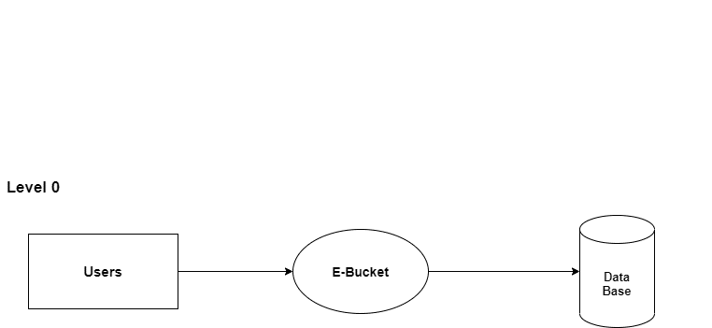

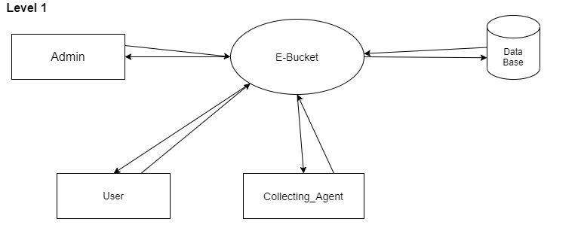

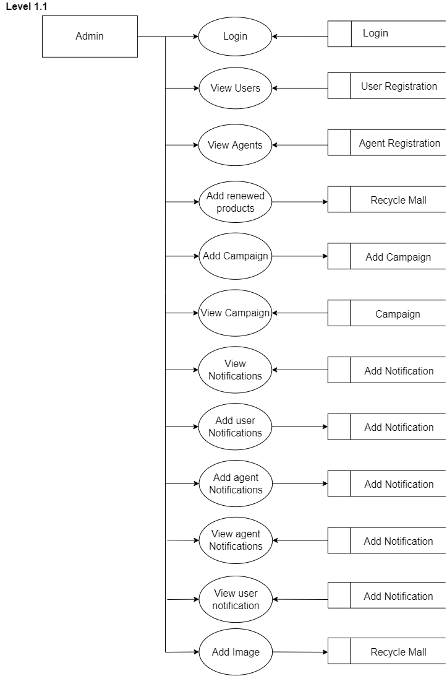

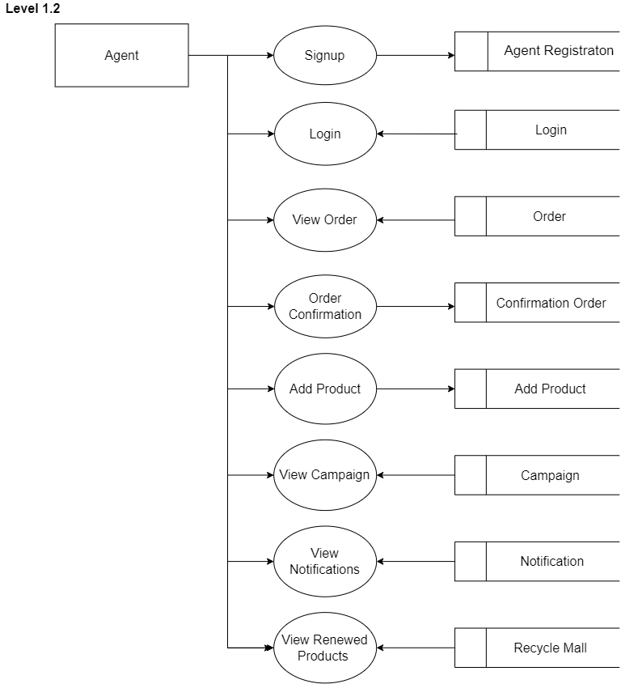

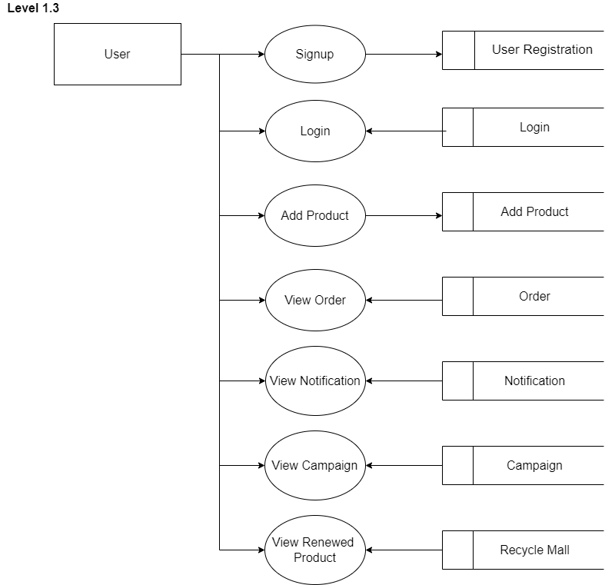

**5.5 DATABASE DESIGN**

The general objective is to make information necessary, quick, inexpensive and flexible for the user. Database allows the data to be protected and organized separately from other resources. A database is a collection of interested data stored with minimum redundancy to serve many users quickly and efficiently. The general objectives considered in database design are controlled redundancy, case of learning and use, data independency, more information at low cost, accuracy and integrity, recover from failure, privacy and security performance.

In a database environment, the Database Management System (DBMS) is the software that provides the interface between the data file on a disk and the management, they differ in the way they structure data. The three types of data structures are hierarchical, network and relational. Here we use relational structuring in which all data and relationships are presented in a flat, two- dimensional table called a relation. A relation is equivalent to file.

Data structuring is refined through a process called normalization. Data are grouped into simplest way possible, so that later changes can be made with a minimum impact on data structures. Based on the requirements determined during the definition phase of project life cycle, the data elements describing the entity were determined. They are later submitted to normalization to remove redundancy and to optimize them.

Database objectives:

• Eliminate redundant data spontaneously

• Integrate existing datafiles

• Share data among all users

• Incorporate changes identifies easily and quickly

• Simplifies the use of datafiles

• Lower the cost of storing and retrieving data

• Improve accuracy and consistency

• Provide data security from unauthorized use

• Exercise central control over standards

**Document-Oriented NoSQL**

Document-Oriented NoSQL DB stores and retrieves data as a key value pair but the value part is stored as a document. The document is stored in JSON or XML formats. The value is understood by the DB and can be queried.

**Collections Used**

### Collection Name: user

### Document Id: uid

Fields

|  |  |  |
| --- | --- | --- |
| **Field Name** | **Data Type** | **Description** |
| Name | String | Used to store e mail id |
| Mobile Number | String | Used to store phone number |
| User Type | String | Type of the user |
| Address | String | Used to store address. |
| Password | String | Used to store password |
| Location | String | Used to store location |
| Pin | String | Used store pin |
| District | String | Used to store place |
| Uid | String | Used to uniquely identify the document |
| Status | Number | Show status |
| Date | Date time | Create date |
| E mail id | String | Used to store email id. |

### Collection Name: Recycle Product

### Document Id: Apid

Fields

|  |  |  |
| --- | --- | --- |
| **Field Name** | **Data Type** | **Description** |
| Product name | String | Used to store name. |
| Description | String | Used to store description. |
| Price | String | Used to store price. |
| Apid | String | Used to uniquely identify the document |
| FileName | String | Image name |
| Url | String | Image url |
| Status | Number | Show status. |
| Date | Data time | Create date. |

**Collection Name:** **Campaign.**

### Document Id: Cid

Fields

**Page no 40**

|  |  |  |
| --- | --- | --- |
| **Field Name** | **Data Type** | **Description** |
| Title | String | Used to store title. |
| Description | String | Used to store description. |
| Link | String | For link. |
| Cid | String | Used to uniquely identify the document |
| Status | Number | Show status. |
| Date | Date time | Create date. |

### Collection Name: User notification.

### Document Id: unid

Fields

|  |  |  |
| --- | --- | --- |
| **Field Name** | **Data Type** | **Description** |
| Title | String | Used to store title. |
| Description | String | Used to store description. |
| Unid | String | Used to uniquely identify the document. |
| Status | Number | Create date. |
| Date | Date time |  |

### Collection Name: Agent notification.

### Document Id: Anid

Fields

|  |  |  |
| --- | --- | --- |
| **Field Name** | **Data Type** | **Description** |
| Title | String | Used to store title. |
| Description | String | Used to store description. |
| Anid | String | Used to uniquely identify the document. |
| Status | Number | Show status. |
| Date | Date time | Create date. |

### Collection Name: orders

### Document Id: oid

Fields

|  |  |  |
| --- | --- | --- |
| **Field Name** | **Data Type** | **Description** |
| name | String | For store name |
| Phone | String | For Store phone |
| Email | String | Used to store email |
| Address | String | Used to Store Address |
| Order Date | Date time | To store date. |
| Uid | String | Used to uniquely identify the document (user id) |
| Oid | String | Used to uniquely identify the document (order id) |
| Url | String | Used to store url |
| Apid | String | Used to uniquely identify the document (add product id) |
| Price | String | Used to store price |
| Product | String | Used for product |
| Status | Number | Show status |

### Collection Name: Auctions

### Document Id: Aid

Fields

**Page no 42**

|  |  |  |
| --- | --- | --- |
| **Field Name** | **Data Type** | **Description** |
| Aid | String | Used to uniquely identify the document (add product id) |
| Eid | String | Used to uniquely identify the document |
| Agen tid | String | Used to uniquely identify the document |
| Agent name | String | Used to store name |
| Agent price | String | Used for Price |
| Date | DateTime | To Create date |
| Status | Number | Show Status |

### Collection Name: Ewastes

### Document Id: Eid

Fields

|  |  |  |
| --- | --- | --- |
| **Field Name** | **Data Type** | **Description** |
| eid | String | Used to uniquely identify the document |
| Category | String | Used for Category |
| Quantity | String | Used for Quantity |
| Price | String | Used for Price |
| Name | String | Used for |
| Uid | String | Used to uniquely identify the document |
| Address | String | Used to Store Address |
|  |  |  |
| Phone | Number | Used for phone |
| Price | String | Used to Store Price |
| Status | Number | ShowStatus |
| Date | DateTime | To create date |

**5.6 MODULE DESCRIPTION**

The platform has 3 major modules and each modules has its features to carry out as follows:

1. Admin Module

2. Collecting Agent Module

3. User Module

**Admin Module**

This module provides the administrator related functionalities. The administrator manages the entire application

1. Login

2. Collecting agent’s approval.

3. View and search users.

4. View and Search collecting agent.

5. Notification Management.

6. View block requests against users and take action (Approve / Reject)

7. Create campaign and Awareness programs.

**Collecting Agent Module**

This module provides functionalities related to Agents. Agents collects the electronic wastes as per the user requests. The major activities that come under the agent module are:

1. Registration.

2. Login.

3. View profile.

4. View notification.

5. View users request (mode of waste) and take action (Approve / Auction price).

6. View occupied details.

7. View check-in details.

8. Send Complaints and view replay

**User Module**

This module provides the functionalities related to users. The user can raise requests to agents for collecting the e-waste. The user can also buy the recycled products in reasonable prices. The main activities comes under the module are:

1. Registration.

2. Login.

3. View profile.

4. Change password.

5. View collecting agents and the affordable price.

6. View delay notification and send replay.

7. Rate collecting agent.

8. Send feedback.

9. Send complaints and view replay

**6.SYSTEM IMPLEMENTATION & TESTING**

**6.1 SYSTEM TESTING**

System testing is a level of software testing where a complete and integrated software is tested. The purpose of this test is to evaluate the system’s compliance with the specified requirements. It makes a logical assumption that if all the parts of the system are correct, the goal will be successfully achieved. The candidate system is subject to a variety of tests: online response, volume, stress, recovery and security and usability test.

It is the process of exercising or evaluating a system by manual or automatic means to verify that it satisfies the specified requirements or to identify the difference between expected and actual results. The testing activities are aimed at convincing the customer through demonstration and actual use that the software is a solution to the original problem and that both the product and the process that created it are of high quality.

It is also used to find and eliminate any residual errors from previous stages and the operational reliability of the system.

**Preparation of Testing Data**

Software testing is a crucial element of software quality assurance and represents the ultimate review of specification, design and coding. Testing represents an interesting anomaly for the software. During earlier definition and development phases, it was attempted to build software from abstract concepts to tangible implementation. The testing responsible for ensure that the product that has built performs the way that the detailed design documentation specifies.

**Methods of Testing**

Testing is the process of finding bugs in a program. It helps to improve the quality of the software. It has to be done thoroughly and with the help of specialist testers. System testing is a process of checking whether the developed system is working according to the objectives and requirements.

The used testing methods are,

• Unit testing

• System testing

• Validation testing

**Unit Testing**

Unit testing of software applications is done during the development (coding) of an application. The objective of Unit Testing is to isolate a section of code and verify its correctness. In procedural programming a unit may be an individual function or procedure the goal of Unit Testing is to isolate each part of the program and show that the individual parts are correct.

Unit testing is usually performed by the developer. Unit testing has the goal of discovering errors in the individual modules of the system where as integration testing is concerned with the decision logic, control flow, recovery procedures, through put, capacity & timing characteristics of the entire system

**System testing**

This testing is done to see if all the system components mesh up properly. After completing the project, the whole testing was done based on control flow and correct output. Here we tested if the project correctly works with the system configurations and other files and the correct result is earned.

**Validation testing**

Validation Testing ensures that the product actually meets the client's needs. It can also be defined as to demonstrate that the product fulfills its intended use when deployed on appropriate environment.

Validation testing can be best demonstrated using V-Model. The Software/product under test is evaluated during this type of testing.

**6.2 SYSTEM IMPLEMENTATION**

Implementation is a stage where theoretical design is turned to the working system. The implementation phase is used to test the developed package with sample data, correcting the error identified, appearing the user of the various special facilities and features of the computerized system. It also involves user training for minimizing resistance to change and giving the new system a change to prove its worth. The successful implementation of the new system depends upon the involvement of the user.

There are several methods for handling the implementation and consists for changing from the old to the new computerized system. The most secure method for conversion from the old system is to run the old and new system in parallel. In this approach; a person may operate in the manual processing system as well as start operating the new computerized system.

Another commonly used method is a direct cut over the existing manual system to the computerized system. The change may be within a week or a day. This strategy requires planning. A working version of the system can also be implemented in one part of the organization and the changes can be made as and when required, but this method is less preference due to the loss of entire system. After the system is Implementation, a review should be conducted to determine whether the system is meeting expecting where improvements are needed.

**6.3 DOCUMENTATION**

The documentation involves collecting, organizing, and maintaining complete record of programs. The documentation deals with the system department with maximum clarity. Each and every process is explained in detail. The various table used by the system with field details are provided. The system uses various kinds of forms to produce well-structured screen formats. These forms are also documented. The output generated by the system constitutes another part.

Documentation of the software provides the following:

Comments

Comments are very useful in documenting a program. It is used to explain logic of the program. It should be used to improve the quality and understand ability of the program. It should not be redundant, incorrect or incomplete.

System Manuals

A good software system must contain standard system manuals. In this the statement is clearly defined, specifies description, detailed flowcharts, and specimen of all input forms and printed outputs.

Operation Manual

A good software package is supported with a good operation manual to ensure the smooth running of the program.

The operation manual must contain the following information:

• Setup and operational details of each program.

• Loading and unloading procedures.

• Starting, running, and terminating procedures.

• List of error conditions with explanations

**7.FUTURE ENHANCEMENT**

The system design is developed in such a way that any further enhancement can be done easily. The integration of updates are very easily in the system.

“E-BUCKET” establishes a mechanism for handling and treatment of e-waste in a safe and sustainable manner. It concentrates on the safe disposal of e-waste because these products contain hazardous elements that can cause real and lasting damage to our natural environment and public health. Recycled material is used to make new products. This reduces the need to mine virgin new materials from the earth, which are limited in supply. It lowers pollution, as the process of mining has an impact on our environment. I wish to implement this application in world wide. So this system has a very big scope in future...

**8.CONCLUSION**

The project entitled “E-BUCKET” is a smart E-waste management system, is a mobile application, which establishes a mechanisms for handling and treatment of e-waste in a safe and sustainable manner. This applications main agenda is to “Reduce, Reuse, and Recycle”, were used electronic devices can be effectively reused, resold, salvaged, recycled or disposed. In this user can choose the appropriate collecting agent by comparing the prices to submit their e-wastes. The users can also buy the recycled products with best prices. The application was implemented and tested in real time on the server and it works error freely. The system is a really user-friendly and it have high protection. All necessary validations are carried out and it is very attractive with the help of dart and flutter. The system is ready for future modification and upgradation.

**9.** **BIBLIOGRAPHY**

Textbooks :

• Sommerville : Software Engineering

• Marco. L. Napoli : Beginning Flutter

• Pressman : Software Engineering

Websites :

• https://www.flutter.dev/

• https://github.com/

• https://Codelabs.developers.com/

